Special Presbytery-wide Mailing
About
CrossReach
We have three items relating to the work of CrossReach to share with Presbyters –
- A booklet produced by CrossReach which describes services being provided within our Presbytery area.
- Details of the Balmoral Run being undertaken by members of Presbytery, and others, in support of CrossReach.
Funds raised will be shared amongst the six CrossReach services within the Presbytery of the North East and Northern Isles. Please support!
- A specific request from CrossReach Counselling Services in Moray for volunteer counsellors.
The important thing is to share all this information with as many people as possible. Please help by sharing with your congregations and further afield.
Any questions, please contact Iain Hunter (iain@ihhmsh.co.uk) in the first instance.

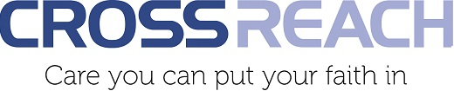

CrossReach Services within the Presbytery of the North East and Northern Isles
There are six different services provided by CrossReach within the boundaries of the Presbytery of the North East and Northern Isles.
CrossReach has prepared a ‘flip book’ for Presbytery to highlight these services and to increase awareness of the work being done within our geographic area.
Presbyters are encouraged to study this booklet and to use the information to promote the work of CrossReach within their own congregation.
The booklet may be found at -
https://flipbooks.crossreach.org.uk/NENI

Presbytery of the North East and Northern Isles
Balmoral Run in support of CrossReach
CrossReach, the Church of Scotland’s social care service, works in several locations within the Presbytery of the North East and Northern Isles (NENI) –
- Buckie – counselling services
- Stonehaven – The Bungalow for adults with profound and multiple learning difficulties
- Banchory - Bellfield Care Home
- Balmedie – Balmedie House (Care Home)
- Scalloway – The Walter and Joan Gray Care Home
- Stonehaven – Clashfarquhar Care Home
An intrepid group of NENI Presbyters is supporting the work of CrossReach in the North East and Northern Isles by running at the Balmoral Running Festival at the end of April 2024. Some are running the 10K and some the 5K races.

In addition to raising funds for the six services within the Presbytery boundary, they seek to raise the profile of the work of CrossReach and show appreciation to the wonderful and dedicated staff:

Presbyters and congregations are invited to support this cause.

Funding raised will be shared amongst the Crossreach services within the Presbytery boundary.

To give via Just Giving, use this link -
https://www.justgiving.com/crowdfunding/running-for-CrossReachNENI?utm_term=e5NejkYn6
Some people may not wish to donate via Just Giving and we would ask that donations are put in an envelope and marked ‘ CrossReach – Balmoral Run’. A Sponsorship Form is attached below and congregations might care to print it out to collect funds
Any funds collected locally should be sent to to Iain Hunter, Mannofield Church, Great Western Road, Aberdeen, AB10 6UZ
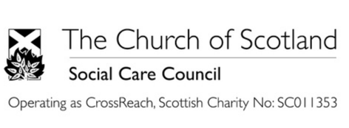

Sponsorship Form for NENI Balmoral Run
Name & Contact info | Amount | Paid

CrossReach Counselling volunteers work across a range of specialities and locations. In particular, CrossReach runs a very busy counselling service in Buckie.

One of the major constraints is the lack of volunteer counsellors and what follows is for anyone who might be interested in training to become a counsellor for the Buckie service.

CrossReach Counselling: Moray works in supportive, holistic teams that deliver exceptional counselling services to clients when they need it most, whilst consistently working to the highest professional and ethical standards.
As a volunteer counsellor with CrossReach, you will be providing a professional counselling service to clients. The necessary training will be provided to allow you to practice within our guidelines.
If you would like to volunteer with us as a counsellor, CrossReach asks that you have completed a diploma in counselling or are currently undergoing a counselling diploma and have completed your readiness to practice. For perinatal services you should have completed a minimum of 50 clinical hours. If you would like to see clients online, you need to have completed an ACTO approved online training course.
Once you have passed your interview stage, CrossReach will apply for a PVG Membership for you, whether this be a new membership or an update to an existing membership.
As with all CrossReach services, openness and respect towards CrossReach’s Christian Ethos is of paramount importance.
For more information and on how to apply, please email: moray.clinical@crossreach.org.uk

