MID DEESIDE CHURCH - THE CHURCH OF SCOTLAND

JOB DESCRIPTION:

Title of Post: Youth and Children’s Worker, Mid Deeside Church, Torphins

Responsible to: This is a locally funded appointment; you will be responsible to the Line

Manager as designated by the parish church.

Hours: 9.37 hours

Date: August 2025

Main Purpose of post: Through a programme of dynamic youth work, to reach out and demonstrate,

in practical ways, Christian care for the wellbeing of the children and young people of Mid Deeside Parish.

___________________________________________________________________________

MAIN DUTIES

• To get alongside the children and young people of the villages and build relationships

with them.

• To work with the young people, creating a nurturing environment which will help them

develop into capable, confident individuals.

• In particular, to share the good news of Jesus with them and to create opportunities

for them to begin to explore the Christian faith for themselves.

• To work in partnership with the local church, plan and help lead Sunday Club , monthly youth club, and quarterly Messy Church.

• To recruit and maintain a rota of Sunday Club, Youth Club and Messy Church Volunteers.

• To provide information e.g., prayer points to enable church members to pray for and

engage with the project.

• To support and develop children/young people’s work already in place in the church.

• Through training, to develop and maintain appropriate skills and to stay abreast of

modern developments in areas relevant to the post.

• To review the progress made at appropriate intervals and to

communicate that progress and future plans to the Management Group.

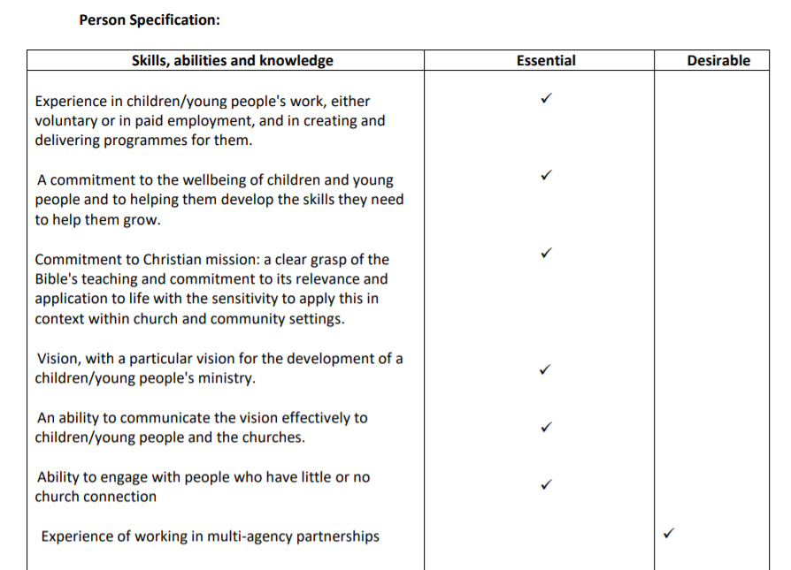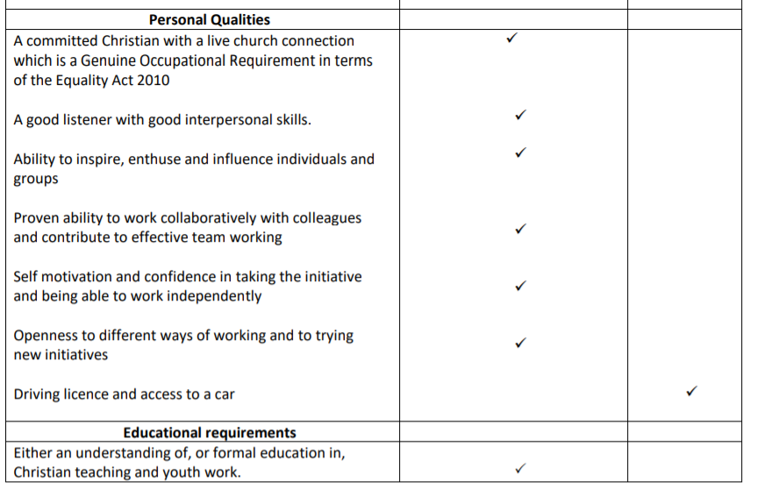

Terms and Conditions:

• Salary is based on the MDS full time scale £27,433 – 31,024 per annum. The successful candidate will start at point 1 of a 5-point scale and move up the scale in annual increments.

• Normal hours of work will be 9.37 hours per week (0.25 FTE). The nature of the work calls for a degree of flexibility, thus hours of work, which are as agreed with the line manager, may vary from day to day, including evening and weekend work.

• There are 5 weeks paid leave in each full holiday year which runs from 1 January to 31 December. Entitlement is based on full weeks worked. There are also 9 statutory holidays. Entitlement increases after 5 years’ service to 6 weeks annual paid leave.

• The post is based in Torphins, Kincardine O’Neil, and Lumphanan.

• Travel expenses by public transport or by use of own car (if appropriate) at rates agreed by the Employer are payable and reviewed annually.

• In view of the nature of the post, the postholder will be required to have membership of the Protecting Vulnerable Groups Scheme.

• In order to comply with the Asylum and Immigration Act 1996, the successful applicant will be asked to provide document(s) confirming their eligibility to work in the United Kingdom.

Informal enquiries can be made to Rev. Holly Smith at [hollyreneesmith@gmail.com](mailto:hollyreneesmith@gmail.com)