ST ANDREW’S SCOTTISH CENTRE LTD

(St Andrew’s Scots House Hotel in Jerusalem)

DIRECTOR RECRUITMENT

Become a member of the Board of Directors, and bring your time and talents to support the Church of Scotland in the Holy Land

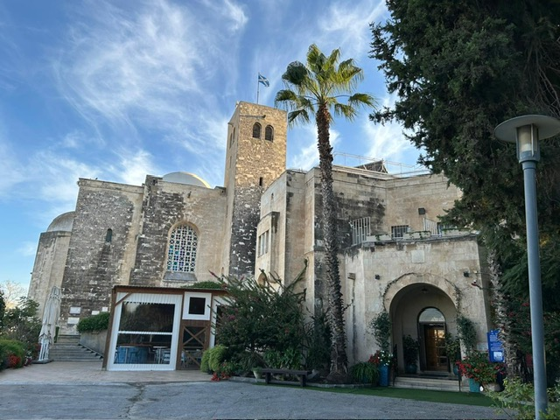

The Church of Scotland
The Church of Scotland’s vision is for a Church that inspires the people of Scotland, and beyond, with the Good News of Jesus Christ - through committed worship, spiritual witness, and connecting with communities in a way that supports our faith and nurtures our connection with Christ.
As a strand to this mission, the Church has property in Jerusalem which currently operates as a commercial hospitality business.
St Andrew’s Scots Memorial Church and Guesthouse were built in Jerusalem to honour the many Scottish soldiers who died in the Palestine Campaign of the First World War. Field Marshal Viscount Allenby laid the foundation stone on 7 May 1927 and the building was dedicated on St Andrew’s Day 1930. In recent years, the Guesthouse has become the St Andrew’s Scots House Hotel, recognising the changing nature of tourism.
This business is respected within the hospitality sector in Israel, recognised for its principle of adhering to employment and trade practices encased within Christian ethics and values.
The Holy Land has historically been the scene of social, religious and political cultures where division is prevalent. In contrast, the St Andrew’s Scots House Hotel operates with equality – an inclusive culture where the diversity of humanity is welcomed to stay, socialise, celebrate, or work and serve.
In this way, alongside delivering high quality hospitality, we are holding a unique space for people of different faiths or no faith to be together and experience each other in a Christian environment.
The Role
As a member of the Board of Directors of St Andrew’s Scottish Centre Ltd, you will play a crucial role in overseeing the strategic direction and mission fulfilment of the Scots House Hotel (hereafter ‘Hotel’).
Your responsibilities will include ensuring the Hotel operates on a stable and profitable financial basis and contributes positively to local communities and tourism while reflecting Christian values. The role of the Board is clearly defined in the Church of Scotland’s Israel Palestine Committee Scheme of Delegation, which can be made available on request.
We are looking for people with relevant skills who feel called to become involved. Please see below for further details on responsibilities and requirements.

Responsibilities and Requirements
Governance Oversight
- Actively engage in Board meetings, discussions, and decision-making processes to provide strategic direction and oversight for the Hotel.
- Ensure that the Hotel’s operations, programmes, and services are consistent with the Church of Scotland's ethos, beliefs, and commitments to Christian principles, social justice, and community engagement.
- Uphold the highest standards of governance, ensuring compliance with legal and regulatory requirements in the UK and Israel.
- Work cooperatively with fellow Board members to establish and review the mission, vision, and strategic goals of the Hotel.
- Ensure that the Hotel complies with all applicable laws, regulations, and industry standards, including those related to hospitality, employment, taxation, and charitable activities.
Fiduciary Duty
- Exercise fiduciary responsibility by overseeing the financial affairs of the Hotel, including budget approval, financial reporting and asset management.
- Monitor financial performance to ensure responsible stewardship of resources and alignment with the Church's financial policies and guidelines.
- Work closely with the Church of Scotland and its Israel Palestine Committee to assess financial risks and develop strategies for sustainable growth.
Strategy and Policy Development
- Contribute to the formulation and implementation of long-term strategic plans to ensure the Hotel is operating on a stable and profitable financial basis, to safeguard its operations, reputation, and long-term sustainability.
- Work cooperatively with Hotel management and fellow Board members to develop, review, and implement policies, procedures, and standards related to hospitality, guest services, employee relations, and ethical conduct.
Advocacy and External Relations
- Serve as ambassadors for the Church of Scotland’s presence in the Holy Land, advocating for its mission and values within the local community, across the communities of Scotland, and beyond.
- Foster positive relationships with local communities, churches, ministries, and other stakeholders in the Holy Land and in Scotland to promote understanding, cooperation, and mutual benefit, in accordance with the Church's commitment to peacebuilding, and interfaith and intercultural dialogue.
Risk Management and Evaluation
- Identify, assess, and manage risks and opportunities related to the Hotel’s operations, reputation, and long-term sustainability, in partnership with management and relevant stakeholders.
- Participate in the evaluation of Board performance, individual director effectiveness, and organisational outcomes, and take or recommend corrective actions as needed to improve governance and operational effectiveness.
- Monitor the performance of the Hotel against established goals and objectives, through regular assessments and evaluations.
- Ensure accountability and transparency in all aspects of the Hotel’s operations, fostering a culture of continuous improvement.
Qualifications and attributes
General Requirements
- Commitment to the Christian mission and values of the Church of Scotland’s presence in the Holy Land, including diversity, inclusivity, and excellence.
- Familiarity with Christian ministry, mission outreach, and social justice initiatives, particularly within the context of the Church of Scotland's global engagement.
- Strong communication, interpersonal, and diplomacy skills, with the ability to build consensus, resolve conflicts, and represent diverse perspectives.
- Cultural sensitivity, respect for diversity, and a willingness to engage with people of different backgrounds, cultures, and faith traditions.
- Integrity, ethical leadership, and a commitment to upholding the highest standards of accountability, transparency, and ethical conduct.
- Ability to travel occasionally to Israel for Board meetings, site visits, and special events.
Specific Requirements to be met across the Board of Directors
- Demonstrated leadership experience in hotel management, hotel operations, human resources, governance or related fields, with a track record of strategic thinking and decision making.
- Financial literacy and understanding of budgeting, financial reporting, and non-profit financial management.
- Experience in Human Resource Management and strategic employment planning.
- Experience in marketing and promotion, ideally in the hotel sector.

Reporting
The Board is a semi-autonomous body which operates within the framework of the Committees and rules of the Church of Scotland as determined by the General Assembly of the Church of Scotland.
Location
While the House Hotel is in Jerusalem, Board meetings take place online, or in person in Edinburgh. Annual visits, arranged and funded through the House Hotel, will be required.
Time Commitment
On average, 5 two-hour meetings per annum, plus preparation time, alongside an AGM. At times of critical importance, a greater time commitment may be required.
Term of Office
The term of office for a member of the Board of Directors is typically four years, with the possibility of renewal based on performance and willingness to continue serving the Church of Scotland’s mission in the Holy Land.

The opportunity
Due to a number of recent resignations after long service, we are currently seeking a number of new members of the Board of Directors. You will be joining a small group of professional, passionate and committed people with a range of experience who are called to be actively engaged in the work of the Church of Scotland in the Holy Land. This role is unpaid but associated expenses shall be met.

Equal Opportunities
We welcome applications from all suitably qualified candidates. Please contact Kenny Roger, Secretary to the Board if you would like to discuss any accessibility requirements. His details are outlined below.

Contacts
If you would like to talk through any aspect of this role, please contact either of those below: we would be delighted to have a discussion with you.
George Russell, Chair of the Board - russellgt@virginmedia.com
Kenny Roger, Secretary to the Board - kroger@churchofscotland.org.uk

Due Diligence
Individuals who express an interest in the role will be provided with all necessary information to enable them to make an informed decision, taking into account the legal responsibilities of company directors, and the trading context of St Andrew’s Scottish Centre Ltd.

How to Apply
Please provide a tailored CV and covering letter outlining why becoming a member of the Board of Directors interests you and the gifts which you would bring to our work.
These should be returned by 31 August 2026 to Kenny Roger, Secretary to the Board – kroger@churchofscotland.org.uk

